WAY UP 2025

The “Way Up” retreat is an adventure designed to be active yet accessible to the needs of all participants. Above all, it is an opportunity to connect with the outdoors and embrace new cultural experiences in a unique context. Enjoy 7 days among the mountains and the enchantment of the Trentino Dolomites, in the company of the Campo Base staff and volunteers, local instructors and guides and other young adults who have had a cancer diagnosis.

This is the application to participate in the Way Up International Session (September 2025). Your answers will help us to get to know you and help us put together a group of maximum 15 participants.

We ask you to take the time necessary to calmly read all the questions and provide the requested information in as much detail as possible, so that we can create a safe and appropriate program and be aware of the needs of each person. Please do not hesitate to contact us if you have any doubts or questions while completing this application.

We ask that you please do not withhold any potentially relevant health concerns, as we are committed to achieving the highest possible standard of safety (physical and emotional) or our participants and staff and it is important that we be aware of any relevant information to be able to achieve this.

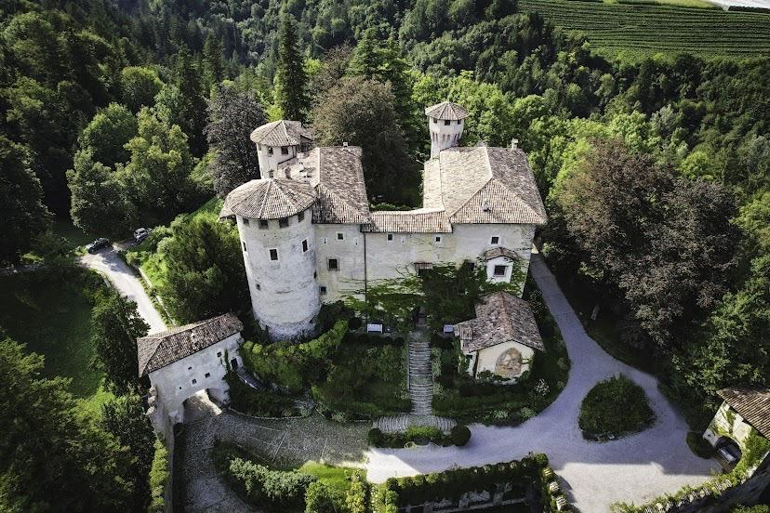

|  |  |  |
| --- | --- | --- |
| Participation application  WAY UP - International session - 2025  Form A - To be completed by applicant  Please send completed form to: [connect@associazionecampobase.org](mailto:connect@associazionecampobase.org) | | |
| PART I – Participant info | | |
| Full Name:       ___________________ | | |
| This application is only for the International Session: Dates 13-20 September 2025 | | |
| Contact in case of emergency  Name and telephone number:    Relationship with the participant: | | |
| General Info | | |
| Date of Birth: |  | M F X |
| Address: | | |
| Cell Phone: | Email: | |
| Please let us know if you are employed/a student/other (optional): | | |
| Medical Information | | |
| Cancer diagnosis: | | |
| Diagnosis date: | | |
| Are you currently receiving medical care that relates to this diagnosis?? Y / N (Please describe) | | |
| Are you receiving maintenance care? Y / N (If yes, please specify) | | |
| Are you in remission? Y / N Remission since (date): | | |
| Have you had any relapses? Y / N Date of most recent relapse: | | |
| Have you undergone chemotherapy? Y / N Date of most recent chemotherapy: | | |
| Have you received radiotherapy? Y / N - If yes, in which part of the body: | | |
| Please list any other medical conditions: | | |
| At which hospital/clinic/medical center were/are you treated? | | |
| Please list all surgeries you have received: | | |
| Please list all medication you are taking and details:  *Name of med - Dosage - Intake - Day/Time - Notes* | | |
| Do you take your medication autonomously? Y / N | | |
| Do you currently have a CVC or port? Y / N - Do you have any open wounds? Y / N | | |
| Are you able to bathe in a bathtub/pool/lake? Y / N | | |
| Could bumps or bruising lead to serious health complications for you?    Describe any difficulties with vision, hearing, balance. | | |
| Do you have any amputations/prosthetics? Y / N | | |
| Do you use any walking aids (crutches, wheelchair, other)? Y / N - If yes, please describe | | |
| Do you have any difficulties with the use of your limbs? Y / N - If yes, please describe | | |
| Can you climb a 4M vertical ladder without assistance? Y / N  Can you climb 3 flights of stairs without assistance? Y / N | | |
| Do you have lung or circulatory complications, e.g. deep vein thrombosis? | | |
| Have you ever had vertigo/dizziness/feelings of instability or loss of balance? Y / N - If yes, please describe) | | |
| Have you ever had a seizure? Y/N | | |
| Do you have cognitive or sensory challenges? Please describe. | | |
| Have you had a tetanus vaccination? Date of last recall: | | |
| Please list any allergies (food, animals, medication, environmental, plants, dust etc.): | | |

|  |
| --- |
| PART II – Program |
| Immagine 1165723394 |
| 1. Briefly describe your sports and outdoor activity experience and whether you are currently physically active (e.g. do you go for daily walks or play sports)? Please note: Living a “sporty” lifestyle is NOT a requirement for participation! 2. Do you suffer from insomnia or have difficulty sleeping? 3. Would you be comfortable sharing a room with other participants of the same gender? |
| 1. Have you ever experienced symptoms of prolonged depression, burnout or mental health challenges that have limited your daily life and could affect your potential participation? 2. After reading the program description packet available for download at   <http://www.associazionecampobase.org/wayupenglish> , please describe other issues that could be relevant with the activities proposed in the program.  (other health issues, limitations of any nature, anything not yet mentioned above …) |
| Part III - Tell us more! |
| How did you hear about Way Up/Campo Base? |
| Why do you want to take part in the program? |
| Are there any aspects of this program that concern you? If so, which ones, and why? (Accommodation, cost, activities..) |
| Which elements of the program are you most excited about? |
| Please tell us something you want us to know about you! |

Thank you so much!

Please send completed form including the following signature pages to :

[connect@associazionecampobase.org](mailto:connect@associazionecampobase.org)

AUTHORISATION AND RELEASE

FOR RECREATIONAL ACTIVITIES and PERSONAL INSURANCE

I hearty declare that I,

applicant (name, surname)_____________________________ DOB (dd/mm/yyyy)____________________:

Have read and I AGREE or I DO NOT AGREE (Please circle one) to the following:

Activities with Campo Base

I am aware that, during my stay with Castel Campo and the APS ETS Base Camp Association, participants will be able to engage in recreational activities (excursions, camping, sports and activities, etc.) carried out with the preparation of specific precautions and suitable safety measures aimed at preventing risks of accidents and under the supervision of expert and competent personnel appointed by Castel Campo and the Campo Base Association to manage these activities.

1. In the event of injury to me, I hereby consent and authorize the administration of all treatments and tests that may be considered advisable or necessary in the judgment of any qualified medical personnel; and

2. I understand that as a condition of being a participant of listed camp activities or activities that are incidental or related to the same, I will provide complete medical insurance coverage for any medical expenses which may be incurred. All medical bills will be sent to me for payment or for forwarding to my insurance company.

3. I have read and understood this form and I assume all risks and liabilities which may result from my participation in any and all camp activities including, but without limitation to the following: swimming, rock climbing, rappelling, white water rafting, archery, climbing wall, sailing, bushcraft, camp out, hiking, nature trail, etc.

4. I assume all risks and liabilities which may result from my participating as a general participant and release and forever discharge and hold harmless Castel Campo and Campo Base Association, its employees, representatives, and agents from any and all actions, causes of action, claims, demands and liabilities arising out of injury to or damage sustained by me.

5. I agree to indemnify the Campo Base Association against any and all liability or loss, and against all claims or actions based upon or arising out of damage or injury to persons or property caused me.

________________ _________________________

Date Signature

(This agreement is MANDATORY for being considered for participation.)

AUTHORISATION AND RELEASE FOR

PROCESSING OF PERSONAL DATA (data privacy)

I AUTHORIZE I DO NOT AUTHORIZE (Please circle one)

Associazione Campo Base APS and Castel Campo to carry out/have carried out the processing of my personal data for the purposes and with the methods indicated in the information form above and in the information sheet here attached and available from the Association website.

(This authorization is MANDATORY for being considered for participation, as we are unable to retain your form on file or even read it without your expressed approval.)

For further information contact info@associazionecampobase.org

________________ _________________________

Date Signature

AUTHORISATION AND RELEASE FOR

USE OF MY IMAGE

I AUTHORIZE I DO NOT AUTHORIZE (Please circle one)

Association Campo Base APS ETS and Castel Campo to carry out, with the use of any form of technology, recordings of my personal image and to use it for illustrative material (photographs, audiovisuals etc.) in order to promote the work of the organization, for promotional material (brochures, website, social media, etc.), as well as printed media of either Castel Campo or Associazione Campo Base APS.

________________ _________________________

Date Signature

